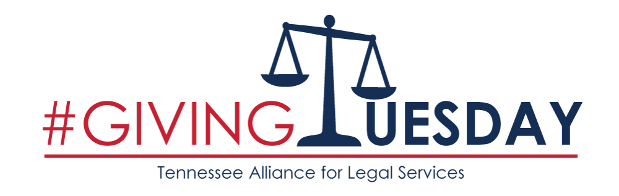
SUBJECT: Tip the Scales for TALS on #GivingTuesday
Dear [Friend],
Did you know that 62% of low-income households in Tennessee experienced two or more civil legal problems in the past year, and six out of 10 of those choose not to take any type of action to rectify legal problems because of costs and not knowing where to turn for help? If unaddressed, problems such as abuse by a caretaker or loved one, unsafe housing conditions, lack of access to healthcare, consumer fraud and family law issues will drive people in need even further into poverty.

That’s why I’m helping the Tennessee Alliance for Legal Services (TALS) Tip the Scales of Justice on #GivingTuesday, and I hope you will too! #GivingTuesday is a global call to action – following Black Friday and Cyber Monday – to give thanks by supporting nonprofits that make a difference in the community. This year, #GivingTuesday is on November 28th.

TALS is a statewide nonprofit organization that strengthens the delivery of civil legal help to vulnerable Tennesseans. To do this, it operates 1-844-HELP4TN – a toll-free phone line, staffed by licensed attorneys, who offers legal guidance and referrals to low-income Tennesseans.

Without the support of charitable donations, TALS’ free helpline cannot support the needs of Tennesseans seeking civil legal advice. I’m helping TALS raise $10,000 on #GivingTuesday to support its civil legal helpline. I hope you’ll join me!
- Donate to ensure people get legal advice and referral from TALS’ helpline
  - $50 helps up to 5 callers
  - $200 helps up to 20 callers
  - Hitting our goal of $10,000 will help up to 1,000 callers
  - Donations of all sizes make a difference
- Share information about TALS and our mission with 3 people
- Forward this email to three friends
- Use this template to spread the word through social media

Visit www.tals.org/giving-tuesday to donate, or click the “Donate” hyperlink above.
Please join me in supporting TALS, and have a happy #GivingTuesday!
[name]

